Nikhil Raina

Information Retrieval

Assessment 2- Retrieval Basics

1. Zipf’s distribution, also called Zeta Distribution, is part of the family of the general exponential distributions that are used to model the size of ranks of randomly chosen objects from certain population types. This shows the relative popularity of a small subset of a population. (Glen, 2016)

Its probability function is shown below:

$$f\left(x\right)=\frac{1}{x^{α}\sum_{i=1}^{n}{{(\frac{1}{i})}^{α}}}$$

Where:

N => is a positive integer

α => is known as the shape parameter, which is equal to or greater than 0. This determines the shape of the distribution

The general curve this distribution invokes is as follows:

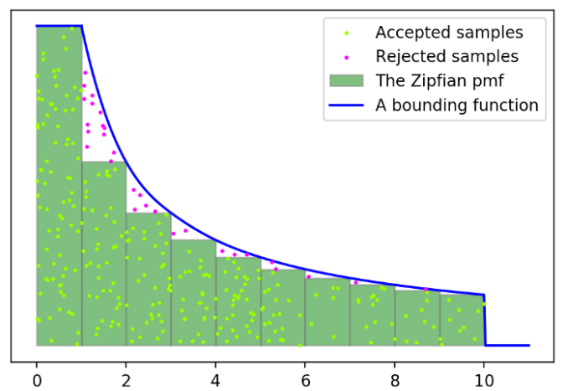

Figure 0.0 (Crease, 2017)

For this assignment, the Figure 0.1 was obtained by plotting frequency of keywords on the x-axis vs the word rank of the corresponding words on the y-axis. Further, the points were arranged in descending order.

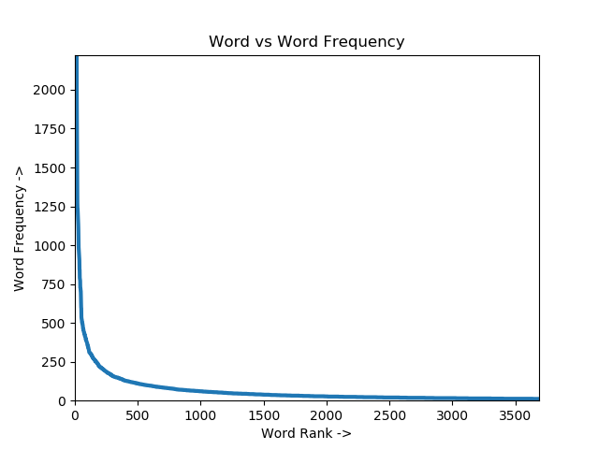

Figure 0.1

By comparing the Figure 0.0 and Figure 0.1, it can be seen that the graph obtained by completing this assessment gives a close resemblance to the Zipr’s Distribution. This means that only a few words from the index.tsv file occur very often.

Upon further analysis of the ordering of the frequency of the words, it was found that number such as 4, 5 and 6 had the highest frequency. Ideally, according to the definition, a stop word is a commonly used word that a search engine has been programmed to ignore, both when indexing entries for searching and while retrieving them as the result of a search query (Dutta, 2020). However, setting these number as stop words would be a bad idea as they could give crucial value for the search query, such as dates, magnitude to a unit, justifying a quantity, etc. Instead of these, it would be better to put articles such as ‘a’, ‘of’ and ‘the’ as stopping words as they were the next most frequent words to be counted during the indexing procedure.

In this assessment, the processing of the text could be handled better. There should be a few pre-decided stopping words that could have been removed while indexing. To further better the processing and understanding of indexing, lemmatization could be used. This would allow words to drop down to their more basic or dictionary form. However, this requires extra computational linguistics power that can identify the part of speech. (Heidenreich, 2018)

1. The following are the results for Disjunctive queries (OR):
   1. With ‘retrieval’ as the query

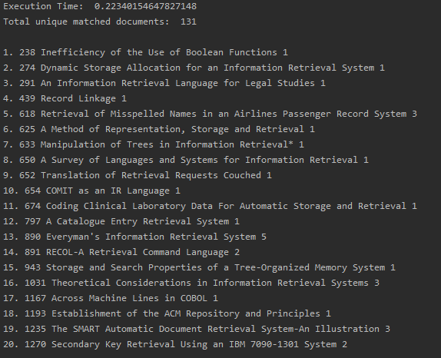

Figure 1.0

* 1. With ‘information retrieval’ as the query

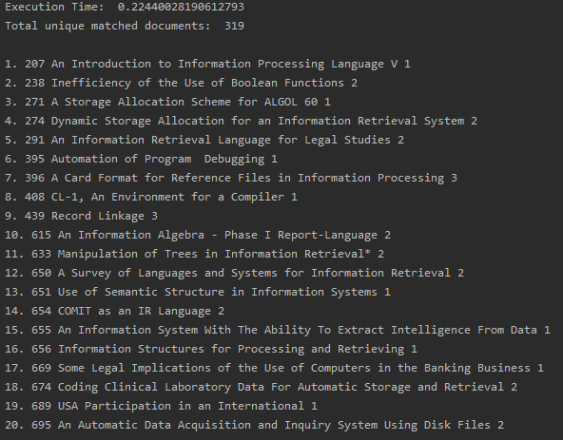

Figure 1.1

* 1. With ‘information retrieval retrieval’ as the query

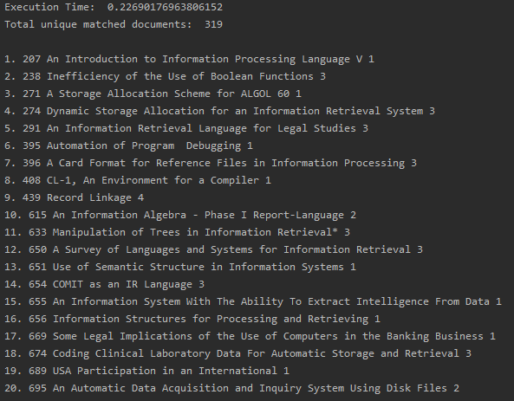

Figure 1.2

* 1. With ‘information retrieval compression’ as the query

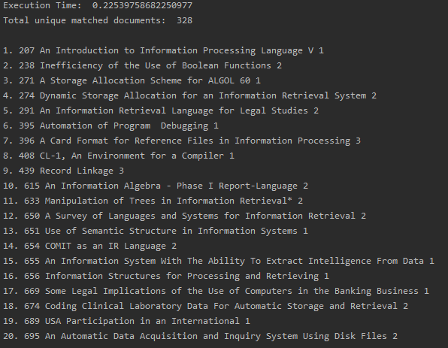

Figure 1.3

1. The following are the results for conjunctive queries (AND):
   1. With ‘retrieval’ as the query

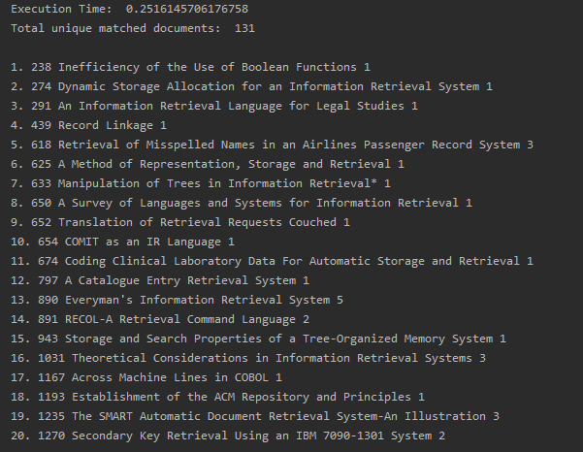

Figure 2.0

* 1. With ‘information retrieval’ as the query

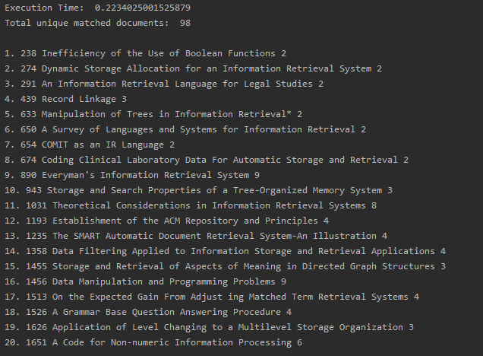

Figure 2.1

* 1. With ‘information retrieval retrieval’ as the query

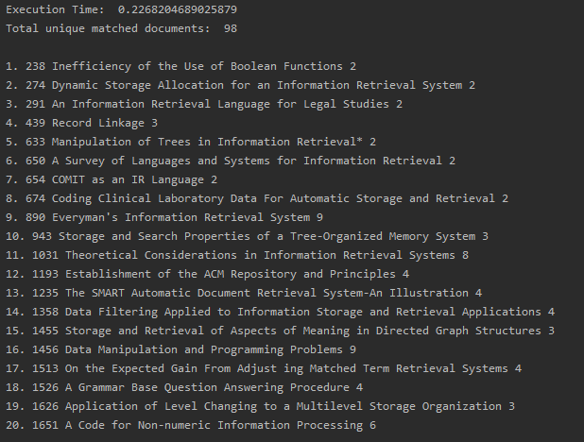

Figure 2.2

* 1. With ‘information retrieval compression’ as the query

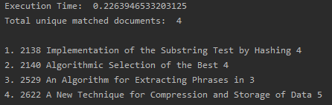

Figure 2.3

All the above results, separately, show the Execution time, number of unique matched documents, the Document ID, title of the document, score assigned to the document and the ranking of the document from the top 20 search results of that specific query.

From the results above, it was observed that Figure 1.0 and Figure 2.0 got the same amount of uniquely matched documents where Figure 1.0’s Disjunctive Query search was 0.03 seconds faster. Not only that, but the relative scores of each document is the same. This makes sense as there was only one query to search for. This behavior isn’t consistent with the other searches as the length of the query increases and bring in similar word search as well.

The second query of ‘Information Retrieval’ obtain different results when comparing the output of the Disjunctive and Conjunctive searches. Figure 1.1 returns 319 matches whereas Figure 2.1 returns only 98. There are a few similarities between the top 20 results, especially the top 5. This kind of behavior, with regards to the difference of uniquely match documents was as expected.

The third query minted a similar result as query two’s did. A few visible differences are in the execution time where the third query taken 0.04 seconds longer to deliver the result. The order of the top 20 matches turned out to be slightly different, where the documents with the higher frequency for the keyword ‘retrieval’ were ranked higher.

For the final query, a massive difference was observed. The figure 1.3 was able to collect 328 uniquely matched documents whereas the Figure 2.3 was able to only collect 4. This meant that the keyword ‘compression’ must have been rarely used in the same documentation as the keywords ‘information’ and ‘retrieval’.

The overall behavior and results that were obtained from the respective searches were went according to plan. The reduction in the matches of keywords in the conjunctive search was as perceived as it was searching the entire set of keywords that occurred in a document, unlike the disjunctive search method where it searched of each keyword as is and didn’t look at the entire set as one unit for search.

Work Cited:

Crease, J. (2017, July 8). *Rejection-sampling The Zipf Distribution*. Medium. <https://medium.com/@jasoncrease/rejection-sampling-the-zipf-distribution-6b359792cffa>

Dutta, A. (2020, May 18). *Removing Stop Words With NLTK In Python - GeeksforGeeks*. GeeksforGeeks. <https://www.geeksforgeeks.org/removing-stop-words-nltk-python/#:~:text=What%20are%20Stop%20words%3F,result%20of%20a%20search%20query.>

Gallagher, J. (2020, July 28). *How To Sort A Dictionary By Value In Python | Career Karma*. Career Karma. <https://careerkarma.com/blog/python-sort-a-dictionary-by-value/>

Glen, S. (2016, July 14). *Zeta Distribution (Zipf Distribution) - Statistics How To*. StatisticsHowTo.Com. <https://www.statisticshowto.com/zeta-distribution-zipf/>

Heidenreich, H. (2018, December 21). *Stemming? Lemmatization? What?* Towards Data Science. <https://towardsdatascience.com/stemming-lemmatization-what-ba782b7c0bd8>

kgkmeekg. (2019, July 23). *Python Code To Remove HTML Tags From A String*. Stack Overflow. <https://stackoverflow.com/questions/9662346/python-code-to-remove-html-tags-from-a-string>